### **How to send an email via Gmail SMTP server using CodeIgniter-4?**

Do you know we can send email from our CodeIgniter-4 web application to others using our personal Gmail? If your answer is “No” then let’s have a look at this article.

#### **Step-1: Change App Access Rule**

First Login to your Gmail account and click on **Your Image Icon** **>** **Manage Your Google Account > Security** as represented below.

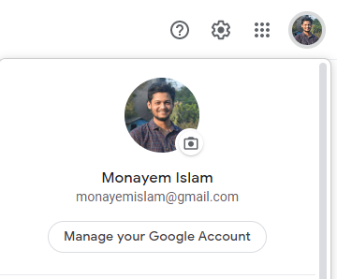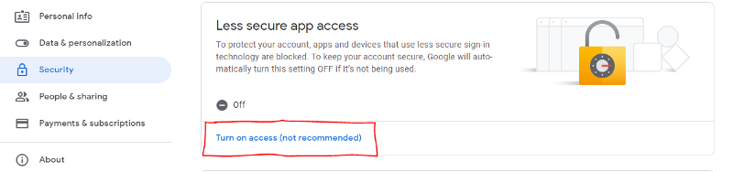

Now, change the **Allow less secure apps** status and make it **ON**.

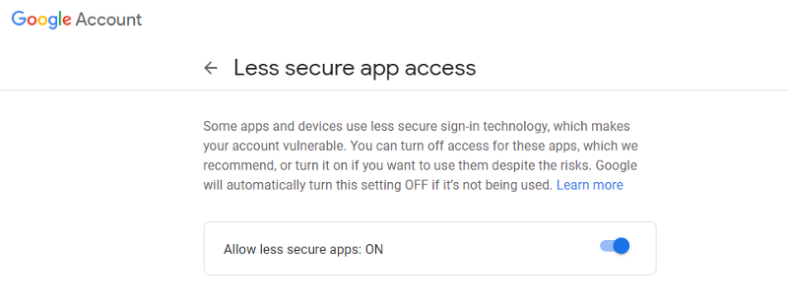

#### **Step 2: Configure Email.php.**

Open **app/config/Email.php** file from your CodeIgniter-4 application folder and provide your Gmail credentials and other parameters value.

<?php

namespace Config;

use CodeIgniter\Config\BaseConfig;

class Email extends BaseConfig

{

/**

* @var string

*/

public $fromEmail;

/**

* @var string

*/

public $fromName;

/**

* @var string

*/

public $recipients;

/**

* The “user agent”

*

* @var string

*/

public $userAgent = ‘CodeIgniter’;

/**

* The mail sending protocol: mail, sendmail, smtp

*

* @var string

*/

public $protocol = ‘smtp’;

/**

* The server path to Sendmail.

*

* @var string

*/

public $mailPath = ‘/usr/sbin/sendmail’;

/**

* SMTP Server Address

*

* @var string

*/

public $SMTPHost= ‘smtp.googlemail.com’;

/**

* SMTP Username

*

* @var string

*/

public $SMTPUser=’example-email-name@gmail.com’;//writhe here your email

/**

* SMTP Password

*

* @var string

*/

public $SMTPPass=’example-password’;//write here your password

/**

* SMTP Port

*

* @var integer

*/

public $SMTPPort = 465;

/**

* SMTP Timeout (in seconds)

*

* @var integer

*/

public $SMTPTimeout = 5;

/**

* Enable persistent SMTP connections

*

* @var boolean

*/

public $SMTPKeepAlive = false;

/**

* SMTP Encryption. Either tls or ssl

*

* @var string

*/

public $SMTPCrypto = ‘ssl’;

/**

* Enable word-wrap

*

* @var boolean

*/

public $wordWrap = true;

/**

* Character count to wrap at

*

* @var integer

*/

public $wrapChars = 76;

/**

* Type of mail, either ‘text’ or ‘html’

*

* @var string

*/

public $mailType = ‘text’;

/**

* Character set (utf-8, iso-8859–1, etc.)

*

* @var string

*/

public $charset = ‘UTF-8’;

/**

* Whether to validate the email address

*

* @var boolean

*/

public $validate = false;

/**

* Email Priority. 1 = highest. 5 = lowest. 3 = normal

*

* @var integer

*/

public $priority = 3;

/**

* Newline character. (Use “\r\n” to comply with RFC 822)

*

* @var string

*/

public $CRLF = “\r\n”;

/**

* Newline character. (Use “\r\n” to comply with RFC 822)

*

* @var string

*/

public $newline = “\r\n”;

/**

* Enable BCC Batch Mode.

*

* @var boolean

*/

public $BCCBatchMode = false;

/**

* Number of emails in each BCC batch

*

* @var integer

*/

public $BCCBatchSize = 200;

/**

* Enable notify message from server

*

* @var boolean

*/

public $DSN = false;

}

#### **Step-3: Make a Controller**

Create a controller **SendEmail.php** to your **app/Controllers** folder . After creating, write a **push** method inside the controller which is given below.

<?php

namespace App\Controllers;

use CodeIgniter\Controller;

class SendEmail extends Controller

{

public function push()

{

$to = ‘destination-name@gmail.com’;//Type here the mail address where you want to send

$subject = ‘Subject of Email’;//Write here Subject of Email

$message=”Conngrats ! You did it.”;//Write the message you want to send

$email = \Config\Services::email();

$email->setTo($to);

$email->setFrom(‘example-name@gmail.com’, ‘Mail Testing’);//set From

$email->setSubject($subject);

$email->setMessage($message);

if($email->send())

{

echo “Email has been Sent.”;

}

else{

echo “Something went wrong !”;

}

}

}

#### **Step-4: Call the push() function**

Now paste the URL (ex: [http://localhost/Email-Sending-Codeigniter4-Gmail-SMTP/public/sendemail/push)](http://localhost/Email-Sending-Codeigniter4-Gmail-SMTP/public/sendemail/push%29) to browser and hit enter ! **Congrats ! You did it.**